Terrain and terrain following in OGRE

Open your project from last week and check that it will still build and run

download the files Terrain.h and Terrain.cpp from breo and put them in the include and src folders of your OGRE project. To add them to the project do Project/Add Existing Item.

At the top of your main.cpp file, add an extra #include statement as follows:
#include "Terrain.h"

Add the following after the other two similar lines at the top of main.cpp
#pragma comment(lib,"OgreTerrain_d.lib")
And the following one after the other two release versions
#pragma comment(lib,"OgreTerrain.lib")

In your main.cpp file, just before the main game while-loop, add a line to load the Terrain as follows:
//Create terrain and give it the current scene manager and the light that will be used to generate shadows
CTerrain terrain(sceneMgr, light);

Try to build your project. If it runs, note that the first time it runs it takes several seconds to get started while it does a one-off rebuild of the terrain. This gets saved in a file called Terrain000.dat in the same folder as the executable. The next time it runs it will hopefully find the dat file and load it which is much quicker than generating it from scratch.

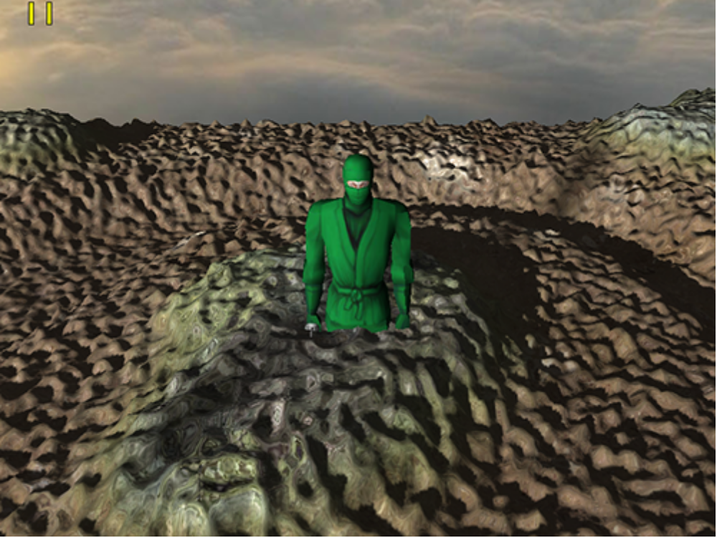Illustration 1: The terrain -note how our Ninja is sunk into the ground
Each time you make any changes to the terrain settings (see below) you will need to delete the dat file so that it generates a new one using the new settings.

To change the shape of the terrain

The height of the terrain is currently defined by a 513 by 513 pixel image called terrain.png which should be in the materials/textures folder.
if you open that image in Photoshop and edit it you can change the shape
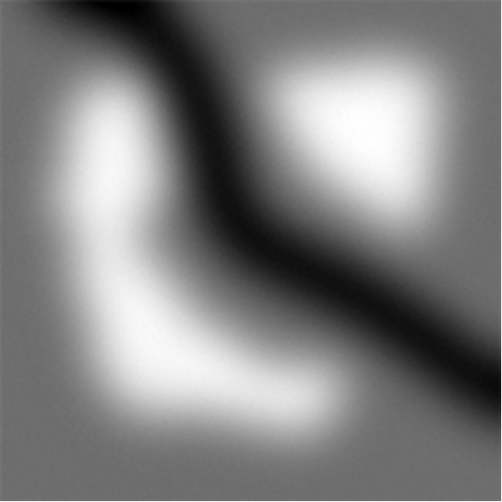Illustration 2: Terrain.png, a 513 by 513 pixel greyscale image edited in Photoshop.

To change the size of the terrain:

in Terrain.cpp, locate the line which creates a new TerrainGroup
m_pTerrainGroup = OGRE_NEW Ogre::TerrainGroup(pSceneManager_, Ogre::Terrain::ALIGN_X_Z, 513, 1000.0f);

the last parameter is the world size of each terrain instance.

To change the height of the terrain

In Terrain.cpp, adjust the inputScale attribute.
defaultimp.inputScale = 10;

To increase the number of terrain tiles
change the values used in the nested loop inside of Terrain.cpp
for (long x = 0; x <= 2; ++x)
{
for (long y = 0; y <= 2; ++y)
{

To make an object sit on the terrain

There is a useful function defined for the TerrainGroup class (which is an attribute inside of the Terrain class) which allows you to determine the height of the terrain at a given world location

float height=terrain.m_pTerrainGroup->getHeightAtWorldPosition(x,y,z);

so to set your player (Ninja, Penguin or whatever) to sit on the terrain you could do something like

mPlayerNode->setPosition(mPlayerNode->getPosition().x,height, mPlayerNode->getPosition().z);

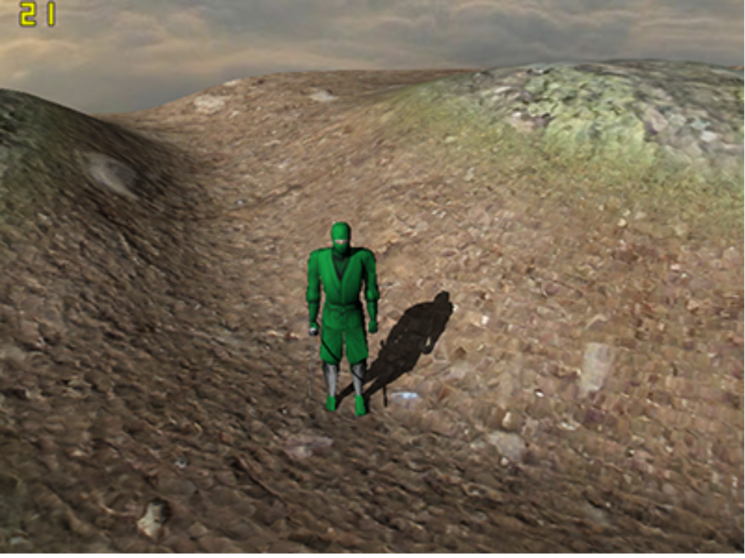Illustration 3: Terrain following enabled - objects such as the Ninja correctly 'sit' on the terrain
To use time-based animation

it is usually a bad idea to hard-code the distance or amount of change to a given property each frame if the frame rate is not fixed. In our case, we don't know what the frames per second will be – this depends on the speed of the computer. To determine the frame time (delta time, dt) download the files Timer.h and Timer.cpp from breo into your /include and /src folders respectively. Import them into your project using Project/Add Existing Item

include the Timer.h header file by adding the following to the top of your main.cpp file

#include "Timer.h"

Now at the beginning of the while-loop, put the following

float dt=CTimer::Instance()->Getdt();

Now you can use this value of dt to control how far things move or rotate etc
eg to move the camera forwards, you might do something like

cameraNode->translate(0,0,-5.0*dt,Ogre::SceneNode::TS_LOCAL);

to add a toggle-wireframe feature
add a new bool variable somewhere near the top of your main function in the main.cpp file

bool bWireFrameMode = false;

within the while-loop, add a new if statement to check for a suitable keypress

if(mInputMgr->getKeyboard()->isKeyDown(OIS::KC_F))
{
if (bWireFrameMode)
{
bWireFrameMode=0;
camera->setPolygonMode(Ogre::PolygonMode::PM_SOLID);
}
else
{
bWireFrameMode=1;
camera->setPolygonMode(Ogre::PolygonMode::PM_WIREFRAME);
}
}
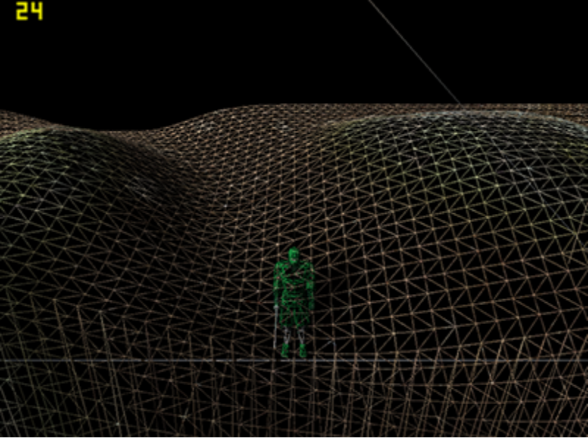Illustration 4: Wireframe rendering switched on

To add a frame listener

We are currently using a 'polling' approach to input detection, whereby within the main while-loop we constantly test to see whether an event has occurred. A more flexible and scaleable method is to use events and event listeners. A central system within the engine generates events at notable moments in the running of the program (eg the beginning of a frame, when the user closes the window, when the user presses a button or moves the mouse). To use events we have to register a listener which will be executed when the specified event occurs.

Download Cameralistener version 1 (.cpp and .h) from breo and put in your /src and/include folders respectively. Add to your project using Project/Add Existing Item.

In order to use this, you need to #include the header file in your main.cpp file as follows:

#include "CameraListener.h"

Now somewhere just before the while-loop, create a new instance of the Cameralistener class and register it with root

CCameraListener * pCameraListener=new CCameraListener();
root->addFrameListener(pCameraListener);

put a break point in the Cameralistener::frameStarted function and check that the listener function is working properly.

Listening for mouse events as well as frame enter events..
We can make our cameralistener also register for mouse move events. Download the cameralistener version 2 from breo and replace the old one.

To register for mouse events you need to add one extra line

CCameraListener * pCameraListener=new CCameraListener();
root->addFrameListener(pCameraListener);
mInputMgr->addMouseListener(pCameraListener,”CameraListener”);

Add a break point into the mouseMoved function and check that it is activated when you move the mouse.

To make the cameralistener control your camera

add an argument to the Cameralistener constructor so that you need to pass into it a pointer to the Camera Node.

CCameraListener(Ogre::SceneNode * pCameraNode_);//do this in the Cameralistener.h header file and also in the cameralistener.cpp implementation file

then when you create your cameralistener in main.cpp, you need to provide it with the actual camera node:

CCameraListener * pCameraListener=new CCameraListener(cameraNode);

Now look at Cameralistener version 3 from breo. Download it and replace the version you have. This now also includes keyboard events, so when you come to activate it you need to add one additional line in main.cpp...

CCameraListener * pCameraListener=new CCameraListener(cameraNode);
root->addFrameListener(pCameraListener);
mInputMgr->addMouseListener(pCameraListener,"CameraListener");
mInputMgr->addKeyListener(pCameraListener,"CameraKeyListener");

use a break point to check that when you press a key it does trigger the keyPressed function.

Now that your Cameralistener knows about the camera node and gets notified when a mouse or keyboard or frame event occurs, we can use it to control the movement of the Camera.

You will notice that the event for keyPressed only occurs at the point of pressing the key – and keyReleased at the point of letting go. We may need to record whether a key is currently down or not. One way to do this is to setup a boolean variable and let the Keypressed function set it to true and the keyReleased function set it to false. Then in the frameStarted function we can check the value of that variable and if necessary move the camera.

float m_fForward_Speed;; //new variable defined in private section of CameraListener.h

m_fForward_Speed=0.0f; //put this in Cameralistener constructor in cameralistener.cpp

now in the keypressed function put something like the following:
if (arg.key==OIS::KC_PGUP)
{
m_fForward_Speed=-10.0f;
}
if (arg.key==OIS::KC_PGDOWN)
{
m_fForward_Speed=10.0f;

}

now in the keyReleased function put something like

if (arg.key==OIS::KC_PGUP || arg.key==OIS::KC_PGDOWN)
{
m_fForward_Speed=0.0f;
}

now, finally in the FrameStarted function, we can make our camera move

m_pCameraNode-> translate(0,0,m_fForward_Speed*evt.timeSinceLastFrame,Ogre::SceneNode::TS_LOCAL);

To look left and look right based on mouse input, we could do something like the following inside the mouseMoved function: (yaw means rotate about a vertical axis, pitch means rotate up and down about a horizontal axis). Note that arg is a parameter which the mouseMoved function recieves, and it contains data about the mouse movement.

float mRotate=2.0f;

m_pCameraNode->yaw(Ogre::Degree(-mRotate * arg.state.X.rel), Ogre::Node::TS_WORLD);

m_pCameraNode->pitch(Ogre::Degree(-mRotate * arg.state.Y.rel), Ogre::Node::TS_LOCAL);

Finally we need the camera to follow the curves of the terrain. The easiest way to do this will be to do something similar to that explained in the 'to make an object sit on the terrain' section above.

A challenge
in this example so far, the alpha matte for the splatting textures has been auto-generated based on the height of the terrain. It is supposed to be possible to use an image file instead – see if you can work out how....

Some things to experiment with
try changing the camera's far clipping plane

camera->setFarClipDistance(5000.0f);

try changing the distance at which OGRE stops rendering the lightmapped version.

m_pTerrainGlobals->setCompositeMapDistance(600);

